LOGO

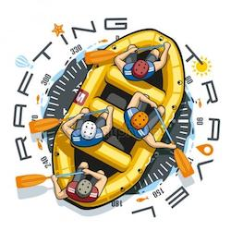

COLOR SCHEME;

URL:

<https://coolors.co/palette/533016-b8936a-9fbace-c6d0d5>

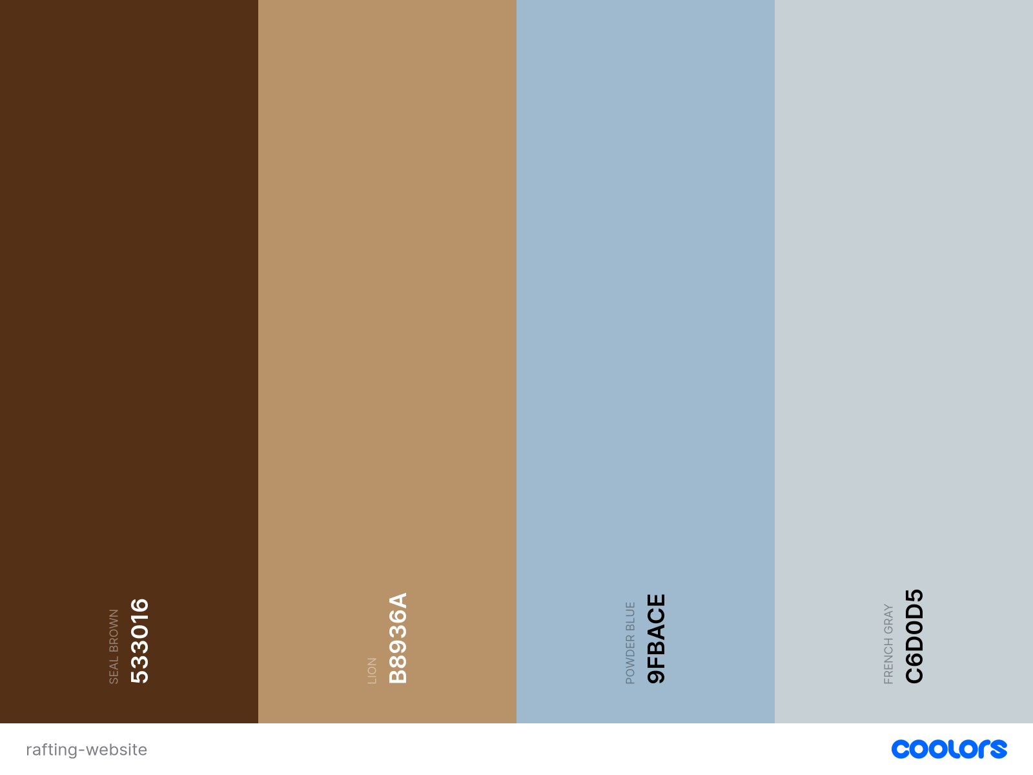

**COLOR CODE:**

PRIMARY SEAL BROWN

SECONDARY LION

ACCENT 1 POWDER BLUE

ACCENT 2 FRENCH GRAY

**TYPOGRAPHY**

Heading: Ancizar Serif - Light 300, Bold 700

Body: Roboto - Regular 400, Thin 100 Italic, Meduim 500